Identifying Communities at Risk for Sudden and Unexpected Infant Deaths Using ArcGIS®

ABSTRACT

Context: In 2004, approximately 4,500 cases of sudden, unexpected infant death occurred in the United States and between 1994 and 2004 there were 1007 SUID deaths in Kentucky.
Purpose: Linking morbidity and mortality rates to geographic areas is a fundamental epidemiological tool, which can be applied to preventing infant death.
Methods: In 2006 the Centers for Disease Control and Prevention funded seven states to record and collect statewide data to clarify certification practices, and identify if state performances fall short of national expectations. Statewide SUID data were retrospectively collected in Kentucky for the years 1999-2005. There were 575 evaluable SUID cases during the study period. For visual analysis of the data, cases were geocoded then spatially joined to the county GIS data layer in a combined data set in order to create maps. Standardized mortality ratio and probability maps were generated and areas with unexpectedly high or low SUIDs identified.
Findings: Of Kentucky’s 120 counties, 42 were found to have SUIDs higher than expected (including 20 counties, 48% considered Appalachian and 86% non-metropolitan). The remaining 78 counties were considered average with an expected number of SUID cases or a lower number of SUIDs than would be expected.
Conclusions: By identifying regions with higher than expected SUID rates communities may be targeted, risk factors (whether geographical or behavioral) identified and possibly prevented. Regions with lower than expected rates offer possible understanding of protective factors. Similar analyses could be undertaken in other states to direct limited resources to appropriate targets, implementing optimal and safe risk reduction strategies, and future pregnancy planning.
Key words: Sudden infant death syndrome, sudden unexplained infant death, mapping analysis, Appalachian, rural

BACKGROUND
In 2004, approximately 4,500 cases of sudden, unexpected infant death occurred in the United States and between 1994 and 2004 there were 1007 SUID deaths in Kentucky (KYDPH, 2004). A diagnosis of sudden infant death syndrome (SIDS) was made in the majority of SUIDs and it remains the leading cause of postneonatal SUID (Hunt, 2006; Moon, 2007; Pediatrics, 2005).
In 2006, the Centers for Disease Control and Prevention (CDC) funded seven states (Georgia, Kentucky, Maryland, Massachusetts, New Mexico, South Carolina, and Wisconsin) with the purpose of identifying differences in investigations, recording and collecting statewide SUID data. This effort sought to clarify statewide death certification practices and determine if state performances fall short of national expectations. The Kentucky SUID pilot surveillance system was implemented in September 2006, building upon the infrastructure developed through the National Violent Death Reporting System (Steenkamp, 2006). The supplemental SUID funding was set in place to collect population-based data, integral to a comprehensive understanding of SUID (Walsh, 2009).
The Commonwealth of Kentucky is one of 12 states home to the Appalachian Mountain Range. The U.S. Census Bureau estimates Kentucky’s 2005 population at 4.2 million residents, 90% of the population self-reported as White, 8% Black, 1% Asian and 2% Hispanic. Of the 120 Kentucky counties, 51 are Appalachian accounting for an estimated 28% of the state’s population (Appalachian Regional Commission, 2009).To determine the degree of urbanization and adjacency to metro areas in addition to Appalachian status, the Rural-Urban Continuum Codes (Beale Codes) were considered (Rural-Urban continuum Codes, 2009). There are 21 counties that meet the most rural code criteria and are also considered Appalachian (Code 9: completely rural with no places with a population of 2,500 or more and not adjacent to a metropolitan area). There are 98 counties (82%) that meet the non-metropolitan criteria (Code 4-9)
Numerous studies indicate health disparities persist in rural and/or Appalachian regions. Geographic isolation, low educational attainments, high poverty rates, health risk behaviors, low number of physicians, and limited job opportunities all contribute to health disparities in rural communities (Behringer, 2006; Carcaise-Edinboro, 2008; Martin, 2008; hendryx, 2008; Tessaro, 2005). We therefore hypothesize that Kentucky counties described as Appalachian and/or rural will have a greater risk of SUID than counties considered metropolitan. This study is relevant to public health research in that it provides insight into regions most at risk for SUID in order to meet the needs of those specific communities, direct limited resources to appropriate targets, and implement optimal and safe risk reduction strategies for future pregnancy planning.

METHODS
The Commonwealth of Kentucky has 120 counties, each with its own elected coroner and a fluctuating number of deputy coroners. The coroner/medical examiner system is a cooperative effort among forensic specialists. The coroners have the full authority of peace officers and are charged with the responsibility of investigating and certifying the cause and manner of all deaths under its statutory jurisdiction, including deaths in children less than 18 years old. In the case of infant deaths, the coroners in each county conduct the death scene investigation, evaluate the sleep environment, collect evidence including the medical and family history, and involve other investigative agencies when applicable. The medical examiners, all of whom are forensic pathologists, from the four regional offices request these documents from the coroners to supplement their autopsy findings from which they recommend to the coroner the cause and manner of death that should be placed on the death certificate. The coroners complete the cause and manner of death on the hard copy death certificate, sends it to the funeral director who then submits the completed document to the Office of Vital Statistics. This information is sent electronically to NCHS where, using the literal text field on the hard copy death certificate, it is assigned an International Statistical Classification of Diseases and Related Health Problems, Tenth Revision (ICD-10) code. Finally, the NCHS returns the hardcopy death certificates back to the sates Office of Vital Statistics who then have these codes entered by a data entry vendor. All information is combined into one record, and the full electronic death certificate file is made available to various agencies (Walsh, 2009).
Death certificate data were collected retrospectively for SUID cases that occurred between January 1, 1999 and December 31, 2005. The CDC designated ICD-10 codes to be used for SUID case identification included suffocation, abuse, undetermined cause, and SIDS. Linked Birth/Infant Death Data, available through the CDC’s query system WONDER, were used for U.S. data comparisons with KY. By compiling several years of data, national trends in SUID case rates can be compared to Kentucky’s rates.
The ESRI Geographical Information Systems (GIS) software (ArcGIS®) was used for visual analysis. Geocoding was used to match the tabulated addresses of the SUID cases with StreetMap USA address locator data. Latitude-longitude coordinate values were automatically calculated and matched. Coordinates for unmatched points were determined by correcting address errors or estimating by zip code. The georeferenced SUID data was then spatially joined to the county GIS data layer in a combined data set to create maps. Individual case points provide a more accurate representation of case distribution and the additional county level count layer provides valuable contextual information. The maps assume the constant risk hypothesis; the risk of sudden unexpected infant death is the same in each of Kentucky’s 120 counties.
Standardized Mortality Ratio Mapping
Dividing the observed case count by the expected SUID count yields the standardized mortality ratio (SMR) and estimates the relative risk of a SUID by comparing an infant living in a specific county versus an infant living outside of the specific county.
(1)

Here yi = the number of cases observed in county i, Ei= the number of cases expected in county i, ni =the number of live births in county i, Y+ = statewide number of SUID cases, and N = the statewide number of live births.
Probability Mapping
Probability maps are exploratory that are more useful with small at-risk populations than typically used rate maps. The probability of no SUID cases in a county was calculated by taking the probability of a birth not being a SUID to the power of the number of live births in that individual county,

(2)

Here, Xi is the number of SUIDs in county i.

Unexpected Probability Mapping

The Probability Map of Unexpected SUID Rates depicts rates of unexpectedly high or low rates when compared to the overall statewide rate of SUID. This analysis combines and summarizes the results of computations (1) and (2).
For counties where SUIDs were observed, the results of the SMR mapping (1) was used. The expected count in each county was calculated using the overall statewide risk estimate. If the observed number of cases was more than twice as great as would be expected, the county was designated as high. For counties where no SUID was observed, the results of the probability mapping (2) were used. If the probability of no SUID in the county, given the number of live births, was less than roughly 1 in 5 it was designated as unexpectedly low. Low, Average, and High counties, based on the above analysis, were then delineated in Map 3.

RESULTS
Figure 1 plots infant death rates from 1995 through 2005 in KY and the U.S. Kentucky was consistently above the national rates of sudden and unexpected infant deaths with a more pronounced difference from 2002 and forward.
Figure 1. Rates of Sudden, Unexpected Infant Deaths in Kentucky and the U.S., 1995-2005
Figure 2 is a map showing the difference between observed and expected SUIDs where a ratio greater than 1.0 indicates that more infant mortality has occurred than would have been expected, and a ratio less than 1.0 indicates that less infant mortality has occurred. In 35% (42) of KY counties SUIDs were higher than expected. There were 26 counties where there were no SUID cases and therefore automatically lower than expected in Figure 2. Figure 3 shows cases where counties were expected to have SUIDs, but didn’t. In 9 counties, the probability of having no SUIDs was unexpectedly low, yet there were no reported SUID cases during the study years.
Figure 2.
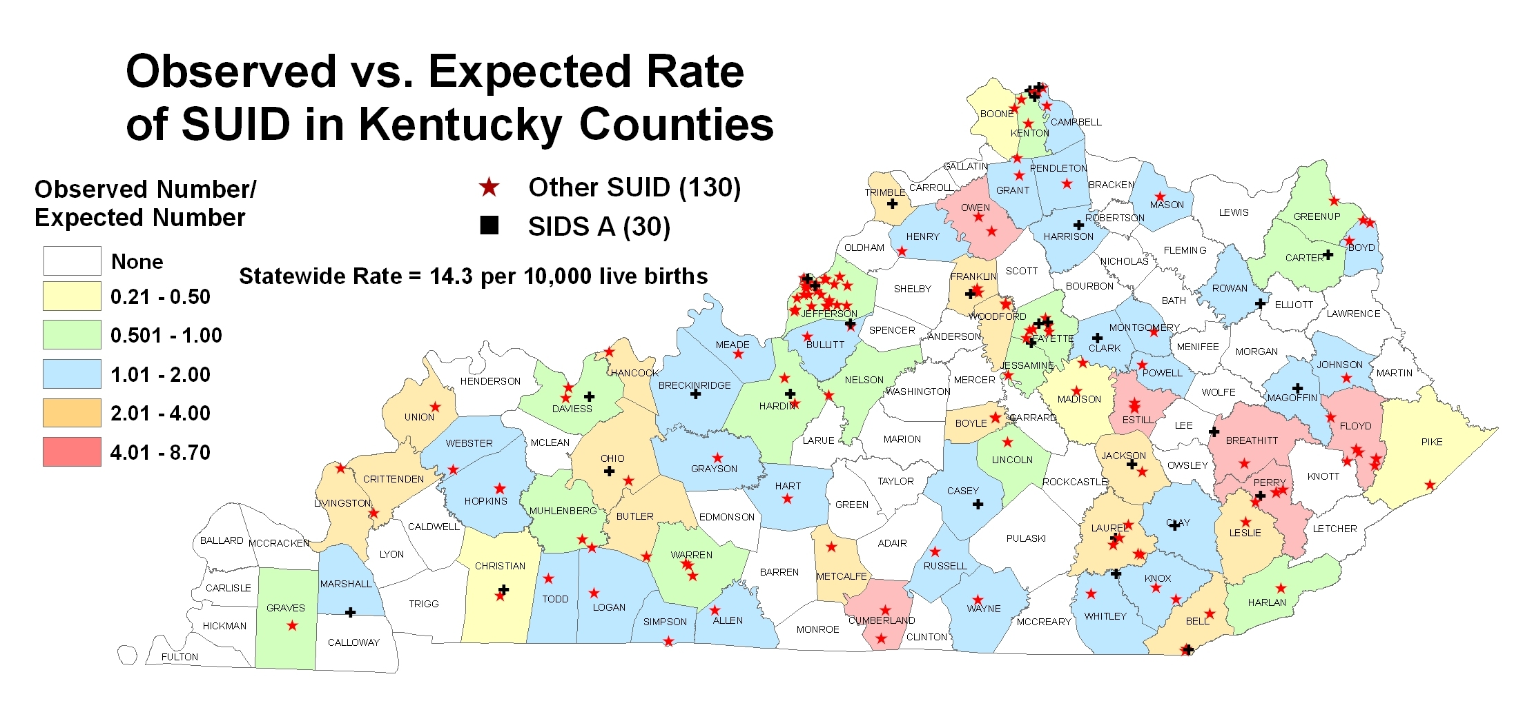

Figure 3.
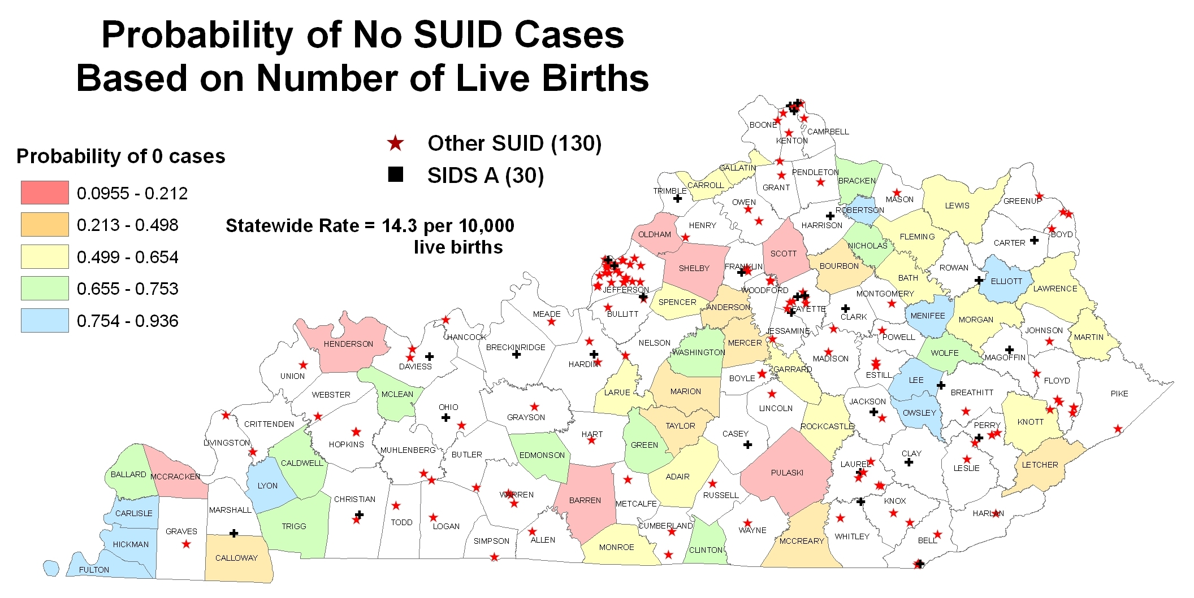

When the maps in Figures 2 and 3 were combined (Figure 4), 10 counties were found to have SUIDs higher than expected and 18 lower than expected. If the SMR > 2, that individual county was considered “Higher” than what would be expected. If 0.5 ≤ SMR ≤ 2 then that individual county was considered similar to what would be expected and is labeled as “Average.” If SMR < 0.5 that county was “Lower” than what would be expected in that individual county.
Figure 4.
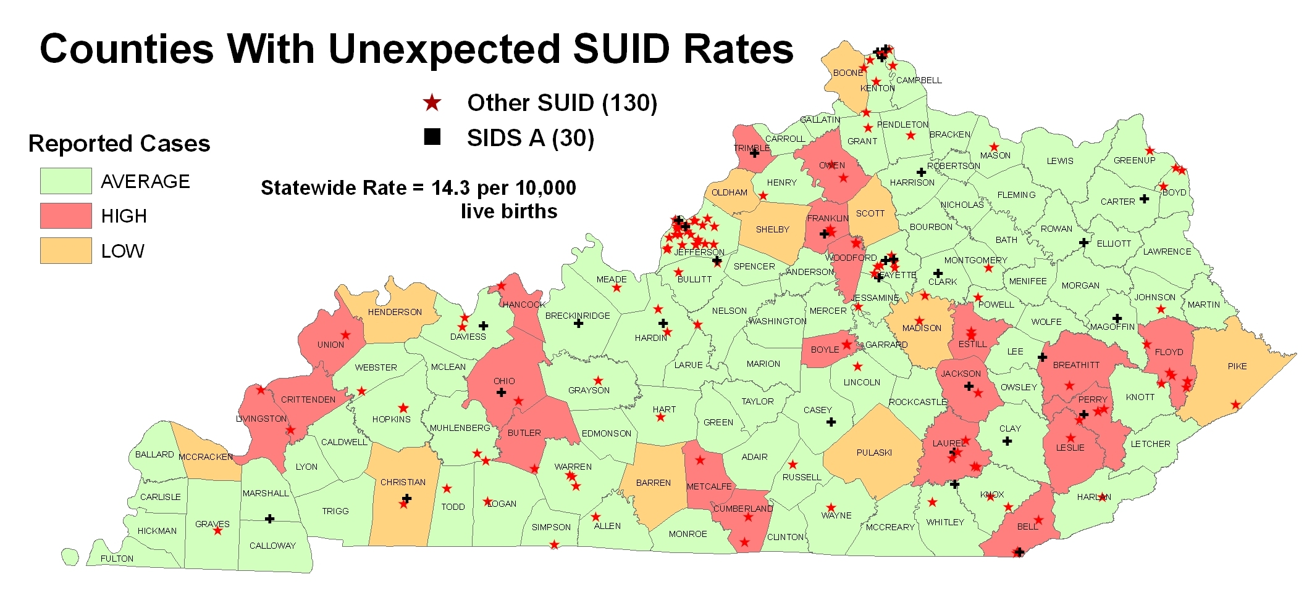
The remaining 92 counties were considered average with an expected number of SUID cases. Of the 10 counties with higher than expected SUID rates, 6 (60%) were designated as Appalachian and of those Appalachian counties, three (30%) also met the most rural Beale Code (Code 9). Of the counties higher than expected, all had populations less than 20,000 and were considered non-metropolitan. Almost half as many counties with the lowest risk (17%), compared with the highest risk of SUID met the criteria for Beale Code 9 (completely rural) and ten (56%) were considered Appalachian.
CONCLUSIONS
By identifying regions with higher than expected SUID rates communities may be targeted, risk factors (whether geographical or behavioral) identified and possibly prevented. Regions with lower than expected rates offer possible understanding of protective factors. For example, Figure 3 shows Pendleton County had an unexpectedly low SUID rate. There were no SUID cases, and, given the number of live births in the county, the probability of no SUID cases was less than 1 in 10. Results such as this can focus questions: what are the protective characteristics in the county; are there community prevention efforts in place; or, are there classification issues in the county causing SUIDs to be underreported?
For years innovative and successful cancer programs in rural communities have been developed, implemented and evaluated (Baquet, 2005; Baquet, 2006; Fouad, 2006). There is limited information about educational campaigns or interventions designed to reduce infant mortality in rural areas. The Appalachian region is known to have elevated social, economic and behavioral risk factors¹⁴ and as this study points out a higher risk of infant mortality within Kentucky’s Appalachian region (Eastern Kentucky) and rural areas. Many individuals living in rural areas have limited access to health care services, particularly primary care settings, where infant sleep safety education (avoiding prone sleeping, co-sleeping, and soft sleep surfaces) is generally delivered to new mothers (Pediatrics, 2000; Pediatrics, 2005).
Secondly, accurately understanding the problem of infant mortality is a vital component when implementing best practices. SIDS is a natural and unexplained death where risk factors contribute to the death. Other SUIDs are cases where behavioral modification might have prevented the deaths and risk factors may have caused, as opposed to contributed, to the deaths. Community interventions with SIDS deaths higher than those deaths caused by sleeping environment would look much different than if deaths due to sleeping environment were higher than SIDS. Improved understanding of the circumstances and causes of sudden infant death is urgently needed to improve prevention for the living. Understanding whether a child died of positional asphyxia, child abuse, or SIDS, or an undiagnosed metabolic disorder or cardiac condition is crucial in protecting not only the general population of new babies but also the specific siblings of the child who dies.
Our study has limitations. For the above mentioned reasons mapping SUIDs separately might prove more useful than mapping all SUIDs together. With the 120 county infrastructure SIDS cases in most individual counties were rare and in this study mapping all cases together proved more beneficial than mapping SIDS cases separately. Combining more years of data for separate analysis might be informative in understanding natural infant death versus possibly preventable infant death in future studies.
We conclude with several recommendations, first being to initiate community capacity building in areas with higher than expected SUIDs (Fouad, 2006). Given the unique disparities in Appalachian and rural areas it is essential to use a community-based model in addressing infant mortality (Fouad, 2006). Successful cancer and diabetes prevention activities might be re-designed for infant sleep safety initiatives (Tessaro, 2005; Fouad, 2006; Bray, 2005). Programs such as incorporating nurse-led case management for new and or expecting mothers into rural primary care practices, patient navigators to provide understandable health education in these underserved populations, and other community-level interventions such as crib distributions should be implemented (Bray, 2005; Schwaderer, 2007).
We also recommend establishing more statewide multidisciplinary pediatric death review teams that meet regularly, in every county, to prospectively evaluate these cases before death certificates are completed. Finally, similar analyses should be undertaken in other states to identify communities at the most risk for sudden, unexpected infant death, especially states in the Appalachian mountain range or with rural populations.

REFERENCES
1. Hunt CE, Hauck FR. Sudden infant death syndrome. CMAJ. 2006;174:1861-1869.
2. Kentucky Cabinet for Health and Human Services, Department for Public Health (Unpublished data, 1994-2004).
3. Moon RY, Horne RS, Hauck FR. Sudden infant death syndrome. Lancet. 2007;370:1578-1587.
4. The changing concept of sudden infant death syndrome: diagnostic coding shifts, controversies regarding the sleeping environment, and new variables to consider in reducing risk. Pediatrics. 2005;116:1245-1255.
5. M Steenkamp, L Frazier, N Lipskiy, M DeBerry, S Thomas, L Barker and
D Karch. The National Violent Death Reporting System: an exciting new tool for public health surveillance. Inj Prev. 2006; 12(S2): ii3-ii5.

6. Walsh S, Kryscio R, Holsinger JW, Krous H. Systematic Evaluation of Sudden, Unexpected Infant Death Classification: Results from a National Pilot Project. Paper presented at: The Society for the Advancement of Violence and Injury Research Annual Meeting, March 5-March 6, 2009; Atlanta, GA.
7. On-line Resource Center Regional Data and Research, Appalachian Regional Commission. Available at: http://www.arc.gov/index.do. Accessed on January 5, 2009.
8. Measuring Rurality: Rural-Urban Continuum Codes, United States
Department of Agriculture, Economic Research Service, The Economics of Food, Farming Natural Resources and Rural America. Available at http://www.ers.usda.gov/briefing/rurality/RuralUrbCon/. Accessed on January 5, 2009.
9. Behringer B, Mabe KH, Dorgan KA, Hutson SP. Local implementation of cancer control activities in rural Appalachia, 2006. Prev Chronic Dis. 2009 Jan;6(1):A34. Epub 2008 Dec 15.
10. Carcaise-Edinboro P, McClish D, Kracen AC, Bowen D, Fries E. Fruit and vegetable dietary behavior in response to a low-intensity dietary intervention: the rural physician cancer prevention project. J Rural Health. 2008 Summer;24(3):299-305
11. Martin CA, McNeil DW, Crout RJ, Ngan PW, Weyant RJ, Heady HR, Marazita ML. Oral health disparities in Appalachia: orthodontic treatment need and demand. J Am Dent Assoc. 2008 May;139(5):598-604; quiz 627
12. Hendryx M. Mental health professional shortage areas in rural Appalachia. J Rural Health. 2008 Spring;24(2):179-82
13. Merwin E, Snyder A, Katz E. Differential access to quality rural healthcare: professional and policy challenges. Fam Community Health. 2006 Jul-Sep;29(3):186-94.
14. Tessaro I, Smith SL, Rye S. Knowledge and perceptions of diabetes in an Appalachian population. Prev Chronic Dis. 2005 Apr;2(2):A13. Epub 2005 Mar 15.
15. Baquet CR, Mack KM, Brambie J, et al. Maryland’s Special Population Cancer Network: caner health disparities reduction model. J Health Care Poor Underserved. 2005 May; 16(2):192-206.
16. Baquet CR, Mack KM, Brambie J, et al. Maryland’s Special Populations Network: A model for cancer disparities research, education, and training. Cancer. 2006 October 15;107(8 Suppl):2061-70.
17. Fouad MN, Partridge E, Dignan M, et al. A community-driven action plan to eliminate breast and cervical cancer disparity: successes and limitations. J Cancer Educ. 2006 Spring;211(1 Suppl):S91-100.
18. American Academy of Pediatrics, task force on infant sleep position and sudden infant death syndrome changing concepts of sudden infant death syndrome: implications for infant sleeping environment and sleep position. Pediatrics. 2000;105:650-656.
19. Force on Sudden Infant Death Syndrome. The changing concept of sudden infant death syndrome: diagnostic coding shifts, controversies regarding the sleeping environment, and new variables to consider in reducing risk. Pediatrics. 2005;116:1245-1255.
20. Bray P, Thompson D, Wynn JD, et al. Confronting disparities in diabetes care: the clinical effectiveness of redesigning care management for minority patients in rural primary care practices. J Rural Health. 2005 Fall;21(4):317-21.
21. Schwaderer KA, Itano JK. Bridging the healthcare divide with patient navigation: development of a research program to address disparities. Clin J Oncol Nurs. 2007 Oct;11(5):633-9.
22. Willinger M, James LS, Catz C. Defining the sudden infant death syndrome (SIDS): deliberations of an expert panel convened by the National Institute of Child Health and Human Development. Pediatr Pathol. 1991;11:677-684.
23. Krous HF, Beckwith JB, Byard RW, et al. Sudden infant death syndrome and unclassified sudden infant deaths: a definitional and diagnostic approach. Pediatrics. 2004;114:234-238.

