December 31, 2019

Dr. Doug Ramsey, Associate Professor of Rural Development, Brandon University
Editor, Journal of Rural and Community Development

Dear Dr. Ramsey:

I am an assistant professor completing my sixth year in that capacity in the Division of Arts Management and Arts Entrepreneurship at Southern Methodist University. I earned my PhD in Public Affairs at the University of Colorado Denver. My work focuses on the sustainability of arts organizations and the practice of creative placemaking. My recent research has explored the issues faced by arts organizations in rural communities and creative placemaking in rural communities.

My co-author, Matthew P. Ehlman, PhD, earned his PhD in Philanthropic Studies at Lilly Family School of Philanthropy at Indiana University Purdue University Indianapolis. His research focuses on rural philanthropy. He is a Principal with the Numad Group located in Rapid City, SD. We have collaborated on several projects exploring the intersection of arts and rural communities.

We are submitting our manuscript, “When in doubt, go to the library? Libraries & rural creative placemaking” to be considered for publication in The Journal of Rural and Community Development. As rural communities struggle to adapt to the knowledge-based economy, many have looked to creative placemaking as a means for renaissance. The American Library Association has articulated the potential of libraries to partner in creative placemaking. This paper asks, “What are the practices and potential capacity of rural libraries as partners in arts programming and creative placemaking?” After reviewing your guidelines for contributors, I feel that my article will fit into The Journal of Rural and Community Development. This manuscript has not been previously published and is not submitted elsewhere for publication.

Thank you for your consideration. I can be reached electronically at bkgallagher@smu.edu and by phone at 303.618.6366.

Sincerely,
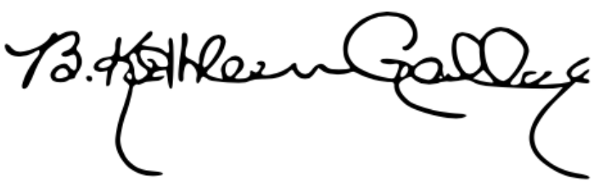
B. Kathleen Gallagher

