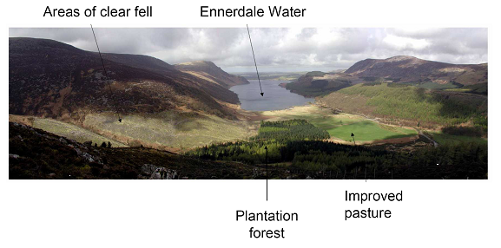
Figure 2. Plantation Forestry in Ennerdale Valley (adapted from WESP, 2006).

