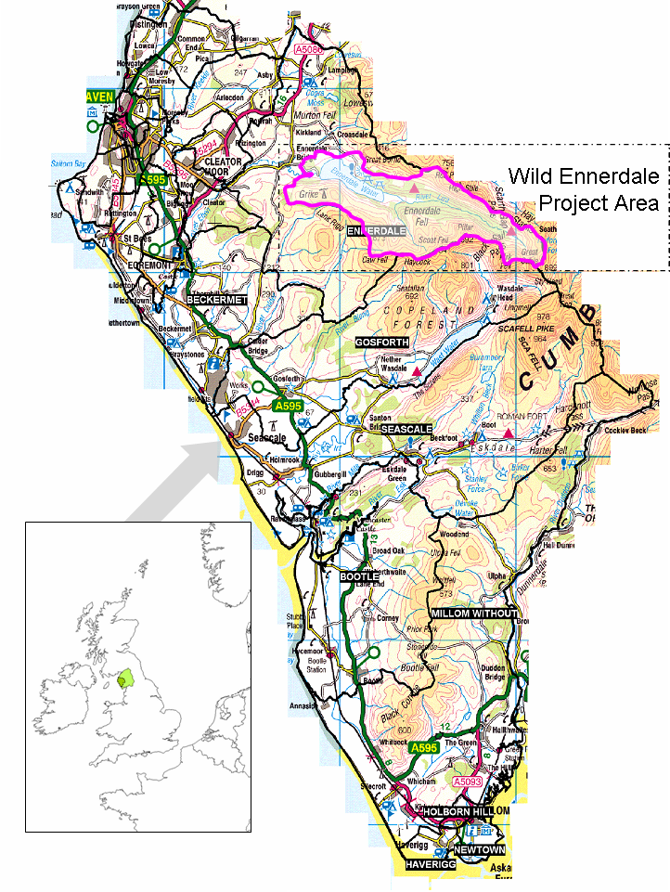

Figure 1. Location of Wild Ennerdale. Inset map indicates location of Cumbria (lighter shading) & West Cumbria (darker shading) within UK (adapted from Cumbria County Council, 2006)

